Asia-China-Coin-Spade-Three Hole-H3.486 R 1-Mould

obv. "下甫" *XiaPu*, rev. "十二朱" *Shi er zhu* (12 *zhu).* length 12.3 cm. / 4.84 in., width 4.15 cm. / 1.63 in., H3.486 R 1-钱范Qián fàn (Money Mould), DCD 364.

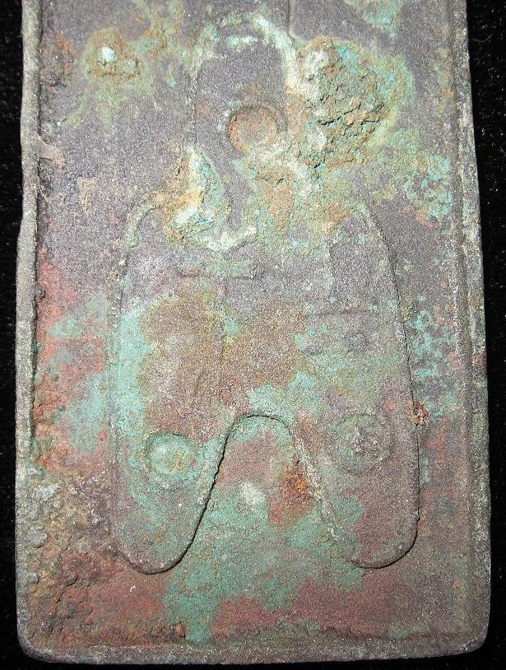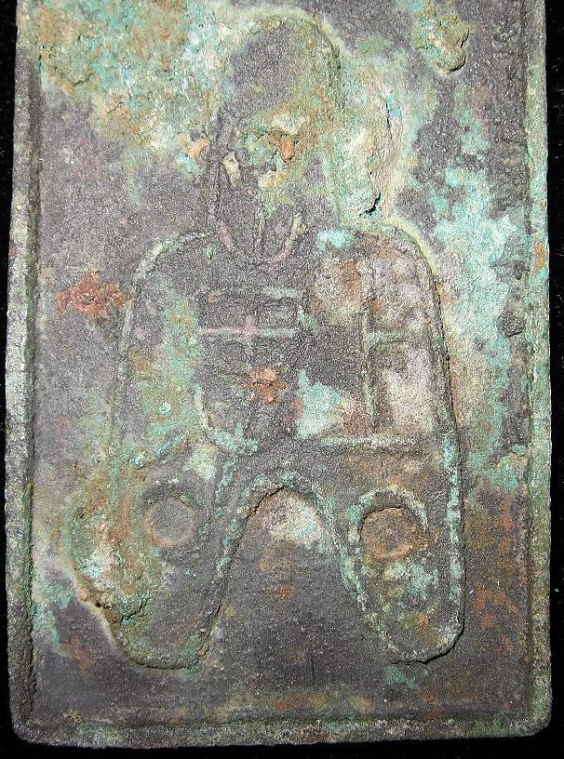

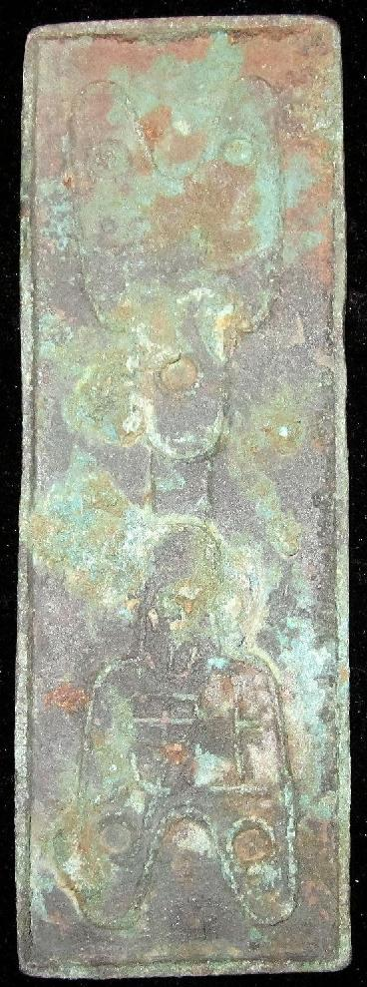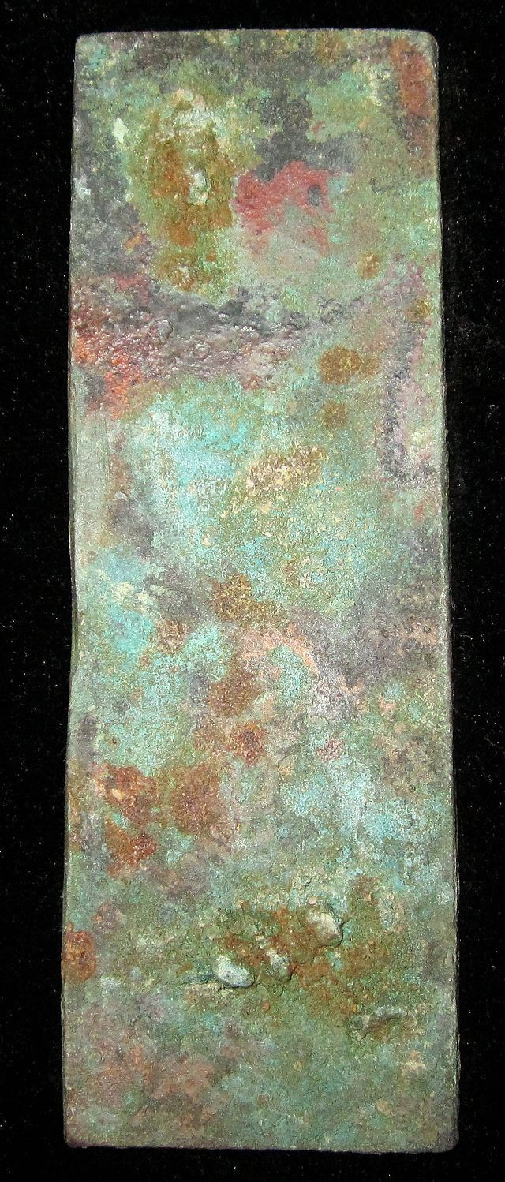 Sold by

[bcculture](http://myworld.ebay.com/bcculture) ( [81](http://feedback.ebay.com/ws/eBayISAPI.dll?ViewFeedback&userid=bcculture)  )

+ Show additional actions

Delivery package 1 of 1

Estimated delivery Thursday, Jan 16, 2014 - Thursday, Feb 13, 2014

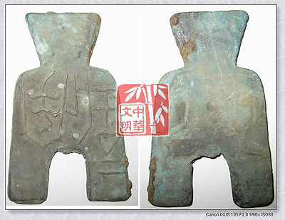

[VINTAGE SpringAndAutumnPeriod WEI MINT WEIGHT MONEY BRONZE SPADESHAPE COIN垂二釿桥裆布](http://www.ebay.com/itm/251408802794)

Item price

$9.99

Quantity

1

Item number

251408802794

Shipping service

Economy Shipping from outside US

[Leave feedback](http://feedback.ebay.com/ws/eBayISAPI.dll?LeaveFeedbackShow&useridfrom=802-867&useridto=bcculture&item=251408802794&transactid=0) [Contact seller](http://contact.ebay.com/ws/eBayISAPI.dll?FindAnswers&frm=3998&iid=251408802794&redirect=0&requested=bcculture) [Return item](http://return.ebay.com/ws/eBayISAPI.dll?ResolveReturn&eventName=viewSelectedItem&TransactionId=0&ItemId=251408802794)

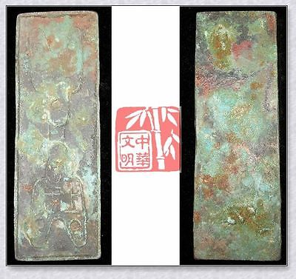

[WARRINGSTATESPERIOD ZHAO NATION MINT MONEY MODEL BRONZE SPADE-COIN PATTERN上专十二朱](http://www.ebay.com/itm/251412020859)

Item price

$59.99

Quantity

1

Item number

251412020859

Shipping service

Economy Shipping from outside US

[Leave feedback](http://feedback.ebay.com/ws/eBayISAPI.dll?LeaveFeedbackShow&useridfrom=802-867&useridto=bcculture&item=251412020859&transactid=1360127104015) [Contact seller](http://contact.ebay.com/ws/eBayISAPI.dll?FindAnswers&frm=3998&iid=251412020859&redirect=0&requested=bcculture) [Return item](http://return.ebay.com/ws/eBayISAPI.dll?ResolveReturn&eventName=viewSelectedItem&TransactionId=1360127104015&ItemId=251412020859)

Sold by

[lengxue](http://myworld.ebay.com/lengxue) ( [27](http://feedback.ebay.com/ws/eBayISAPI.dll?ViewFeedback&userid=lengxue)  )

+ Show additional actions

Delivery package 1 of 1

Estimated delivery Wednesday, Jan 8, 2014 - Thursday, Jan 16, 2014

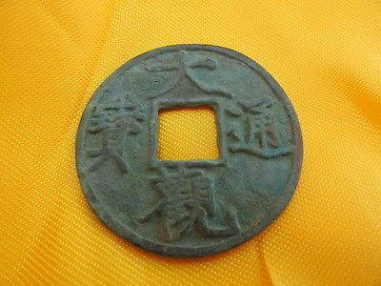

[Artwork Chinese ancient trade tools, bei song period ,da guan tong bao,font](http://www.ebay.com/itm/141146766610)

Item price

$1.85

Quantity

1

Item number

141146766610

Shipping service

ePacket delivery from China

[Leave feedback](http://feedback.ebay.com/ws/eBayISAPI.dll?LeaveFeedbackShow&useridfrom=802-867&useridto=lengxue&item=141146766610&transactid=0) [Contact seller](http://contact.ebay.com/ws/eBayISAPI.dll?FindAnswers&frm=3998&iid=141146766610&redirect=0&requested=lengxue) [Return item](http://return.ebay.com/ws/eBayISAPI.dll?ResolveReturn&eventName=viewSelectedItem&TransactionId=0&ItemId=141146766610)

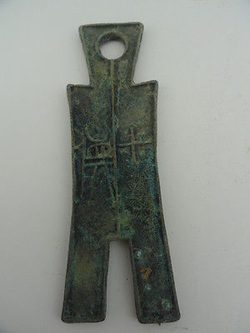

[Tools of the trade in ancient China,spring and autumn period, trousers shape](http://www.ebay.com/itm/141146767474)

Item price

$8.99

Quantity

1

Item number

141146767474

Shipping service

ePacket delivery from China

[Leave feedback](http://feedback.ebay.com/ws/eBayISAPI.dll?LeaveFeedbackShow&useridfrom=802-867&useridto=lengxue&item=141146767474&transactid=0) [Contact seller](http://contact.ebay.com/ws/eBayISAPI.dll?FindAnswers&frm=3998&iid=141146767474&redirect=0&requested=lengxue) [Return item](http://return.ebay.com/ws/eBayISAPI.dll?ResolveReturn&eventName=viewSelectedItem&TransactionId=0&ItemId=141146767474)

### Shipping address

Ralph J Coffman Jr  
149 Atlantic Ave   
Swampscott MA 01907-2427  
United States

Phone number  
781 584 7091

### Order total

Subtotal $80.82

Shipping $52.00

Shipping discount -$3.00

#### Total

## $129.82

[View PayPal transaction](http://payments.ebay.com/ws1/eBayISAPI.dll?IntermediateResolutionInfo&itemid=0&transId=0&pn=UnifiedCheckoutSummaryRedirect2PP&qs=itemid%3D0%26transId%3D0%26buyerorseller%3D0%26)

### Order information

Order placed on  
Sunday, Dec 29, 2013

Having a problem with this purchase?  
[Resolve problem](http://res.ebay.com/ws/eBayISAPI.dll?ResolutionCenter)

Payment method   
PayPal

Payment date  
Sunday, Dec 29, 2013